# One pattern

Here start from 5th frets

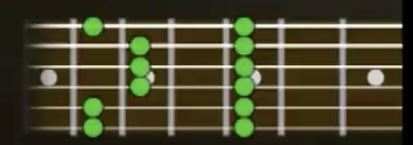

# Transfer it to blues scale pattern

Here start form 5th frets

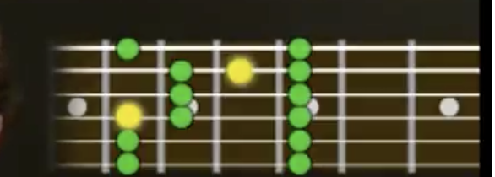

# Transfer it to Major scale pattern

Here start from 2nd frets

